SHOP WITH ME: An E-commerce platform for modern retailers, small and medium retailers with small businesses



Period of creation: three months

Written by: SAAH GUEDEM ROSINE PRISCA

Program and level of study: BACHELOR’S IN COMPUTER SCIENCE LEVEL 4, AT THE ICTUNIVERSITY

Supervisor: Mr. Daniel MOUNE
Academic year: 2025 - 2026

TABLE OF CONTENTS

Certification 3
CHAPTER THREE: WEB SERVICES 7
3.1. Introduction 7
3.2. What are Web Services? 7
3.3. Key Characteristics of Web Services 7
3.4. Benefits of Web Services 8
3.5. Types of Web Services 8
3.6. Real-World Applications of Web Services 8
3.7. Challenges of Web Services 9

Certification

This is to certify that this document by SAAH GUEDEM ROSINE PRISCA, a student at THE ICT UNIVERSITY at Nyom in computer science level 4 is a record of my own work done for the platform for modern E- commerce for modern retailers in compliance with the requirements and regulations governing the evaluation. The work is supervised and approved by a professional supervisor.

Supervisor: Mr. DANIEL MOUNE
Signature: ..................................
Student: SAAH GUEDEM ROSINE PRISCA
Signature: ....................................

CHAPTER ONE: INTRODUCTION

Now our days, students to afford their school fees and feed their selves do trading to sell little stuffs which can give them money. Workers which does full time work though low remunerations turn theirselves to trade to have a plus to afford the necessities for their families, but all of these small retailers to inform everyone about their products and expand their businesses sell their products on the internet. Sole proprietors, entrepreneurs and all those involved in business use internet for the advertisement of their products. The fact is all this small retailers want to sell their items on the internet but need helps to do it properly. Using whatsapp groups and whatsapp status which may not be appropriate so this platform is made to help them.

The platform aims to to empower retailers by facilitating online sales through a user friendly and robust system. The platform will be designed to help small retailers, sole proprietors and small business owners trade online in a secure environment while being informed of users taste. The retailers will sell their products directly to the customers while providing a seamless experience to their customers online.

The platform will focus on a few important things, making sure it can grow when more people use it, keeping it running even if something goes wrong, allowing different retailers to work together, and using good technologies to make everything work easier
CHAPTER TWO: E-COMMERCE

E-commerce refers to the buying and selling of goods and services over the internet. It allows businesses and consumers to conduct transactions without the need for physical interaction. E-commerce has transformed the global market place making trader faster and more convenient and more accessible to anyone with an internet connection. There are several types of e-commerce models, including:
1) B2C (Business to Consumer): Companies sell directly to individual customers like amazon, shein
2) B2B (Business to Business): Transactions between companies like manufactures, wholesailers
3) C2C (Consumer to Consumer): Individuals sell to each other through platforms like eBay.
4) C2B (Consumer to Business): Individuals offer products or services to companies like influencers on social media branding products for companies
Some Key features of e-commerce include online payment systems, electronic data interchange (EDI), digital marketing, and logistics management. E-commerce platforms often provide tools for inventory control, order tracking, and customer service.
Advantages:
- Shopping can can occur 24/7 anywhere so far as you are with internet connection
- All businesses can access global reach and markets no matter your size
- Reduced operational costs compared to when doing the shopping physically
- Personalized customer experiences
Challenges:
- Security risks and risks of hacks and online fraud
- Delivery and logistics issues
- High competition with in the market place
- Dependence on technology and internet access
- Building customer trust may be difficult

The main components which makes up E-commerce include;
- Online stores with websites, or web apps, mobile apps where consumers can browse and purchase products.
- Payments gateways are services that facilitate online payments such as paypal, stripe, and credit card processors.
- Logistics and fulfillment systems for inventory management, shipping and delivery.

Mostly E-commerce trends are mobile commerce through the use of smart phones, shopping through social media platforms like whatsapp, instagram, facebook, tiktok based on customers preferences and taste ,web sites.

E-commerce is a dynamic field that continues to evolve just by impacting on how consumers and businesses interact and transact.

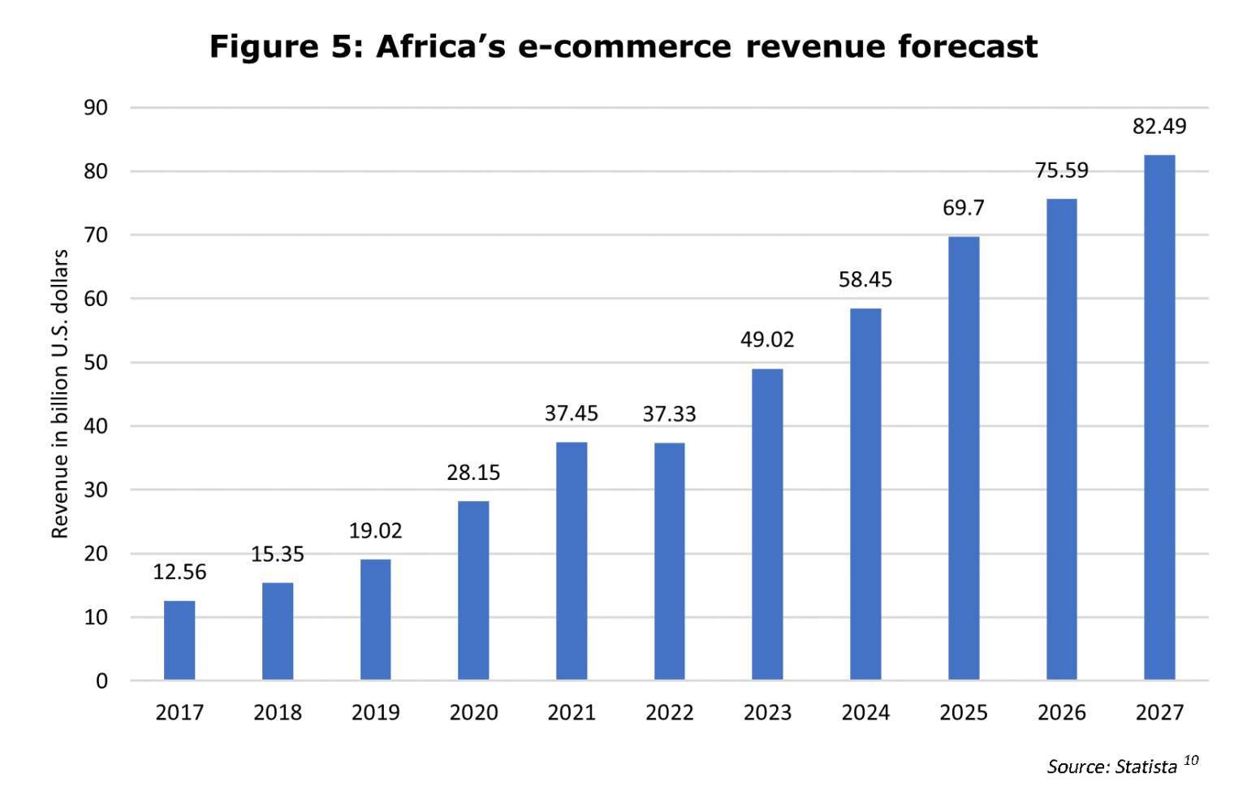

CHAPTER THREE: WEB SERVICES
Web services have become a cornerstone of modern software development, enabling seamless communication and data exchange between applications. This documentation delves into the core concepts, functionalities, benefits, and considerations surrounding web services. It explores various types of web services, communication protocols, and the advantages they offer for businesses and developers. Additionally, the report touches upon potential challenges and best practices for developing and deploying web services.

3.1. Introduction
Imagine a world where applications built with different programming languages and running on various platforms cannot communicate with each other. This was the reality before the advent of web services. Web services bridge this gap by providing standardized interfaces for applications to interact and exchange data over the internet.

3.2. What are Web Services?
Web services act as software components that encapsulate specific functionalities or data. They expose these functionalities through standardized protocols, enabling other applications to access and utilize them. This allows applications built with different technologies to seamlessly interact, fostering a more interconnected digital landscape.

3.3. Key Characteristics of Web Services
1) Standardized Protocols: Web services rely on protocols like HTTP (Hypertext Transfer Protocol).
2) Platform Independence: Web services decouple applications from the underlying platform (Windows, Linux, etc.). As long as they adhere to web service standards, applications can interact regardless of the platform they run on.
3) Language Independence: Programming languages become less of a barrier. Applications written in different languages can communicate seamlessly through web services as long as they follow the established protocols.
4) Loose Coupling: Web services promote a loosely coupled architecture. Applications interact without tight dependencies on each other's internal functionalities, making them more modular and easier to maintain.

3.4. Benefits of Web Services
1) Increased Reusability: Web services enable developers to create reusable components that can be integrated into various applications, saving time and effort.
2) Enhanced Scalability: Web services can be easily scaled to accommodate a growing number of users or requests by adding more servers or resources.
3) Improved Interoperability: Applications built with different technologies can interact seamlessly, promoting a more integrated software ecosystem.
4) Reduced Development Costs: By leveraging existing web services and APIs (Application Programming Interfaces), developers can avoid reinventing the wheel and focus on core functionalities.
5) Faster Time to Market: Web services can accelerate application development by allowing developers to integrate pre-built functionalities offered by web services.

3.5. Types of Web Services
There are various ways to categorize web services, but some common types include:
- RESTful Web Services: A popular architecture that relies on HTTP methods (GET, POST, PUT, DELETE) for data access and manipulation. It offers a lightweight and easy-to-use approach.

3.6. Real-World Applications of Web Services
Web services have a vast range of applications across various industries:
- E-commerce: Product information, shopping carts, and payment processing often involve interactions between web services.
- Financial Services: Secure communication between banks and financial institutions frequently relies on web services.
- Social Media: Sharing content and data between social media platforms often utilizes web services.
- Travel Industry: Booking flights, hotels, and integrating travel information often involves web services. Different travel agencies and service providers can connect through web services to offer a wider range of options to users.
- Supply Chain Management: Tracking inventory, managing logistics, and coordinating with suppliers often involve web services for real-time data exchange.
- Health care: Securely sharing patient information and integrating medical devices can utilize web services with proper security protocols.
- Government Services: Citizen portals, permit applications, and other government services can leverage web services for efficient interaction with citizens.

3.7. Challenges of Web Services
1) Complexity: Designing and implementing robust and secure web services can be complex, requiring expertise in web service protocols and security best practices.
2) Testing and Debugging: Testing and debugging issues across different platforms and applications can be challenging.
3) Standardization Issues: While standards exist, there can be variations in their implementation, leading to potential interoperability issues.

CHAPTER FOUR: THE SHOP WITH ME PLATFORM

4.1 Introduction
SHOP WITH ME is a comprehensive digital platform designed to connect users with multiple services, with a special focus on E-commerce services such as shopping online, orders, and delivery services. The platform serves both customers and administrators (retailer’s staff) by providing seamless management of appointments, orders,payments, deliveries, and notifications.

4.2 Objectives

The main objectives of shop with me are:
- Enable users to shop online.
- Allow users to order items of their choices with delivery options.
- Provide a centralized dashboard for retailers staff to manage orders, deliveries,customer’s taste change and customers notifications.
- Improve communication between customers and retailers for their different styles and change in taste and collaboration between retaillers team.
- Track all transactions, requests, and notifications in real-time.
- To provide a scalable and fault tolerant architecture.
- To foster collaboration among retailers and their teams or different retailers.
- To leverage cloud integration for enhanced functionality and reliability.

4.3 System functionalities

USER MANAGEMENT

- Role base control, define roles such as admins, retailers and customers. Each role having specific permissions for access to ensure security and organised access to the platform.
- User registration and authentification to secure sign up, login processes including email verification and password recovery.

PRODUCT MANAGEMENT

- Retailers can add, edit, rename and delete products listings with images, descriptions and pricing.
- Automate inventory management with alerts for low stocks level and integration with suppliers.

ORDER MANAGEMENT

- Customers can add items to a cart, edit quantities and proceed to checkout with secure payment process
- Provide real time tracking of orders for both retailers and customers to enhance trust

ANALYTICS DASHBOARD

- Generate reports on sales performance, customer demographics and product popularity and product views
- Analyse customer behaviour to refine marketing strategies and improve user experience

4.4 PROBLEM DESCRIPTION

Many small and medium retailers struggle to sell their products online but face some problems like the limited knowledge of new technologies such as websites, payment systems online, customer supports. Some retailers may find it hard to manage this technologies though simple.

The retailers though selling online do not attract customers of the variety of the items they sell.

Setting up traditional E- commerce system can be very expensive which many retailers can’t afford. Many retailers cannot afford to spend a lot of money on technologies.

Retailers often work with collaborators and their teams which they need to share informations and work together but many systems do not allow this easily.

4.5 PROBLEM SCOPE

- The platform will make it easy to use for retailers with limited technical skills.
- The platform can handle many customers without crashing
- The platforms continues running smoothly even if some parts fail
- The platforms will allow many different teams to collaborate and work together
- The platform will be less expensive for small and medium retailers

CHAPTER FIVE: TECHNOLOGIES USED FOR SHOP WITH ME PLATFORM

5.1 System architecture

The system is divided into four main layers:
A. Presentation Layer (Frontend):
- User interfaces for customers: home page, registration, login, retailers page, items page, profile page, dashboard, and notifications.
- Admin interfaces for retailer’s staff: dashboard, request approvals, inventory management, delivery management, commands management, payments managements, and notifications management.
- Business Logic Layer (Backend):
Developed using Django for handling user requests, validating data, managing commands, deliveries, stocks, user taste, and updating notifications. Implements appointment scheduling logic, products availability stocks, and notification generation.
- Data Layer (Database):
MySQL database stores:
Users (customers), retailer’s staff (admin), Commands, items and products inventory, Notifications, Orders and delivery tracking

- Cloud system integration

deploying the website on cloud platforms, cloud base database (firebase), API for payments, google cloud, aws

5.2 Technical stack

- FRONTEND

- HTML
- CSS
- JAVASCRIPT

- BACKEND

- PYTHON WITH DJANGO

- DATABASE

- MY SQL

- CLOUD PROVIDER

- GOOGLE CLOUD OR AWS (still to think about)

- VERSION CONTROL

- GIT
- GITHUB

5.3 Architectural considerations

- Scalability

Using google cloud services to scale resources based on traffic an the demand

Designing the web site in such a way that each component can be scaled independently

Utilising content delivery network to serve static assets quickly and to reduce load on the main servers

- Fault tolerance

To avoid redundancy i’ll implement multiple servers and databases replicas such if one server fails others can take over to ensure continuous availability

Distribute incoming traffic across multiple servers to prevent overload and downtime

For regular backups, schedule automatic backups of data to recover quickly from any incidents

- Collaboration features

Implement features that allow different user roles ; admins, users, retailers.

For real time communication tools, integrate chat and messaging features for teams and different retailers to communicate easily

Allow multiple users to access and analyse performance metrics collaboratively

- Cloud system

Deploying the web site on a cloud based platform that offers high availability, scalability and security

Using google cloud based database to store products data, user accounts and transactions

Integrating payment api with cloud services, inventory management and shipping solutions

Using cloud services for automated backups and disaster recovery solutions

CHAPTER SIX: CALENDAR OF ACTIVITIES

6.1 Implentation plan

Phase 1: Requirements gathering

Collaborate with stake holdres and retailers to gather requirements and materials to define features

Phase 2: design

Create wireframes and mockups for user interface

Phase 3: Development

Implement the frontend and backend components integrating APIS and cloud services

Phase 4:Testing

Conduct unit testing, intergration and some user acceptance testing

Phase 5: Deployment

Launch the platform and monitor it’s performance

6.2 DIVISION OF WORK AND DEADLINES

Week 1and 2

Research and planning what retailers needs and talk to them

Week 3

Create wireframes for the website and planning of the backend architecture

Week 4,5,6,7,8 and 9

Start building the front end of the platform and the setting up the database and backend

Week 10, 11

Test the platform for bugs and issues and gather feed backs from potential users and retailers

Week 12

Make improvements from user taste and returns and retailers and then deploy.

Github link: https://github.com/SaahRosine/shop-with-me-E-commerce-platform-for-modern-retailers.git

